**Day 2 – Congruent Triangles**

1-2. Use the diagrams to create a congruence statement for each set of congruent triangles.

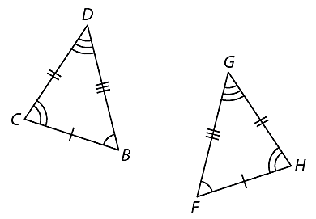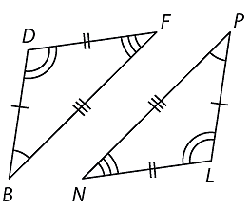

1. 2.

3-5. Name the corresponding angles and sides for each pair of congruent triangles.

3.  4. 

5. Suppose ABC ≅ EFG. For each of the following, name the corresponding part.

 a. ∠A

b. ∠BCA

c. 

d. ∠F

e. ∠GEF

f. 

**If congruent, state the congruence postulate, SSS, SAS, ASA, AAS, or HL. If not congruent, write none.**

6. ___________ 7. ___________ 8. ___________



9. ___________ 10. ___________



11. State what additional information is required in order to know that the triangles are congruent for the reason given.

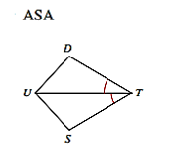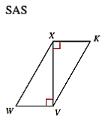

12-15. Identify the transformation used to create  on each coordinate plane. Identify the congruent angles and the congruent sides. Then, write a triangle congruence statement.

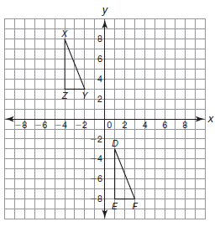12. 13.

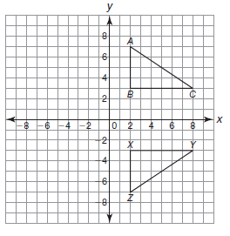

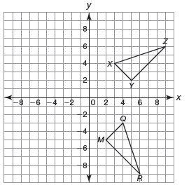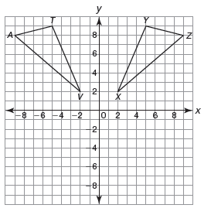14. 15.